Artificial Intelligence [CSE422]  
 Quiz 3 [CO3]

NAME: ID: Section:

____________________________________________________________________________

Question 1:

Let’s say A = injured; ~A = not injured; B = participated in the movement; ~B = did not participate in the movement.

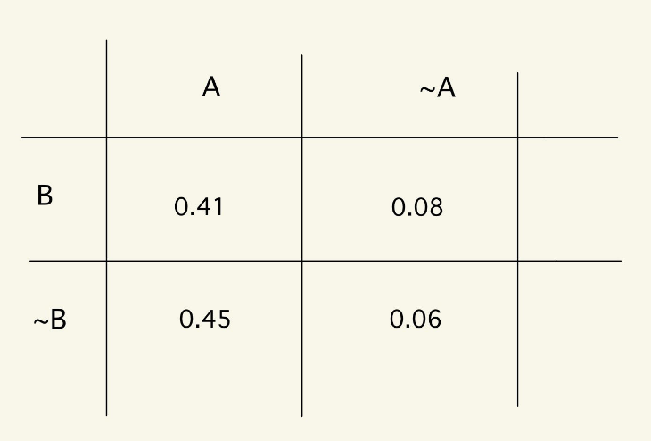

Now answer the following questions:

1. What is the marginal probability of being not injured? [2]
2. What is the probability of being injured given that participated in the movement [3]
3. Is not injured independent of not participating in the movement? [3]
4. What is conditional independence? How do we find it? Explain briefly. [2]